czech glass has been introduced to the W Dubai – THe Palm hotel, where myriad colors plays with light
Walking through the spaces of the brand new W Dubai – The Palm hotel is a bit of a game where you look for the hidden design cues. The W spirit is imbued into the very basis of the hotel including the shape of sound which inspired the new lighting installation made by LASVIT.
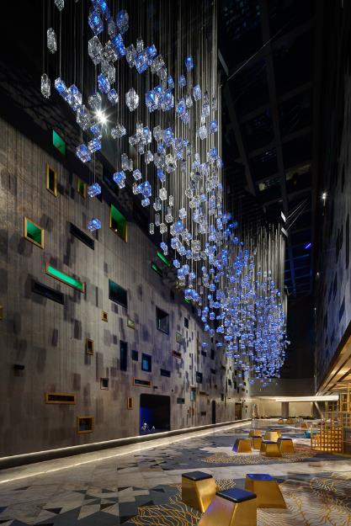
Follow the sound of the music to discover the W essence entangled into the installation above your head right in the entrance lobby.
The witty design of The Soundwave isn’t inspired simply by the shape of the letter “W”, but also, sophisticatedly, by its sound. “The shape is derived from the layout of the graphic record created by pronouncing the consonant W,“ says LASVIT in-house designer Ludmila Zilková, revealing the story behind her design.
The beauty of this piece lies in its hidden plan. When you aimlessly look up, you will see only a 30-meter long construction in an abstract shape. But when you know the story, it rings a bell and each of the 1213 glass pieces will suddenly fit into the overall picture. “Components present single points of sound,“ adds the designer.
A rainbow in millions of color combinations
But it’s only a teaser for the things to come. When the music starts to play, the real show begins. Overall, 640 glass blocks can shine in millions of colors. There are almost endless possibilities thanks to the special DMX chip developed by LASVIT. Employees at the reception of the W Dubai – The Palm hotel can control the installation from the mobile device and play with its light and colors to change the mood of the space.
The Soundwave can “dance” according to a pre-programmed choreography designed for the given music, or change its colors and intensities. The light can also go through the installation like a shoal of fireflies. It doesn’t matter how many times you walk into the W Dubai – The Palm hotel lobby, it will always be a bit different.
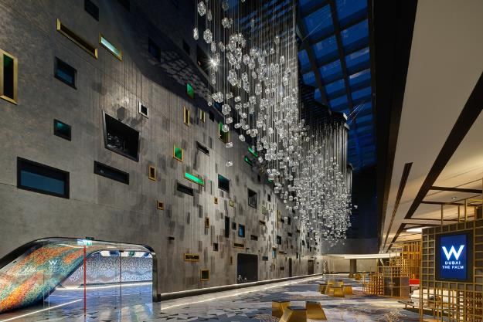
The Soundwave fits in the spirit of the W Dubai – The Palm hotel, which aims to refresh the hospitality scene and boldly reinvents luxury in an inspiring and innovative way. The first hotel from the chain owned by Marriott International was launched in 1998, and now there are more than 50 W´s around the globe. Born out of the irreverent, insatiable and infectious spirit of New York City, the W brand sees the world through a lens of limitless possibilities. This atmosphere reflects their mantra Whatever/Whenever®.
The young and progressive Czech glassmaking company shares this approach, and therefore its design engineers set out to complete a task they had never undertaken before. The Soundwave was one of the most challenging projects LASVIT has ever made in the Middle East also in terms of its construction. The design engineers had to develop and create the laborious structure which the glass components hang from. It had to look like the thin outline of the “W” sound wave, which is drawn on the ceiling, but still be able to cover all the cables and technology necessary for the installation’s proper functioning.
Despite the fragile outlook, the construction bears around 6,5 tones of hanging glass and metal that spans a full ten meters of the ceiling. Every W Hotel draws direct inspiration from its destination and, for W Dubai – The Palm hotel it was the respected interior designers DWP and Mohammad Kafel who set the tone and cooperated with LASVIT to defy expectations and ignite the guests’ imagination.

Notes to editors
About Lasvit
LASVIT is a creative hub of glassmaking talents, fresh ideas, and daring designs. This young, progressive Czech glassmaking and design company inspires the world with its breathtaking custom-made installations exhibited all over the world, as well as with its unique lighting and glassware collections made from hand-blown glass. The founder of LASVIT, Leon Jakimič, steers the company with the utmost respect for the Czech glassmaking tradition, but also with a boundless optimism for modern technologies and cutting-edge design.
In past years, LASVIT has attracted many renowned designers and artists who wanted to collaborate with an unconventional Czech company. In cooperation with LASVIT, many stars such as the Campana Brothers, Kengo Kuma, Yabu Pushelberg, Nendo or Ross Lovegrove, have created some of their most unforgettable glass collections. Ever since 2007, LASVIT has been on a mission: to bring beauty, happiness, and a piece of the Bohemian soul to clients worldwide, and thus change the world for the better. Let LASVIT in, let the changes begin.
#LasvitDesign #LasvitCollections

For further details please contact:
Jitka Plchová,
PR & Communication Manager,
jitka.plchova@lasvit.com,
+420 606 738 522

